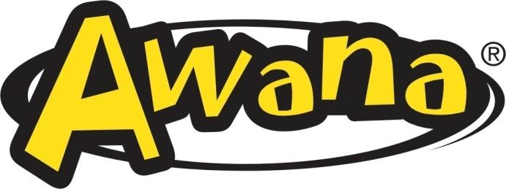

**Price List 2024-2025**

|  |  |
| --- | --- |
| Dues Weekly | $0.50 |
| Dues Yearly | $15.00 |
| All Books | $14.00 |
| Sparks Review Book | $12.00 |
| Sparks Vest | $13.00 |
| Bag* | $7.00 |

*Optional





**Price List 2024-2025**

|  |  |
| --- | --- |
| Dues Weekly | $0.50 |
| Dues Yearly | $15.00 |
| All Books | $14.00 |
| Sparks Review Book | $12.00 |
| Sparks Vest | $13.00 |
| Bag* | $7.00 |

*Optional

